

TASK:

It has been recently suggested that “…gamers have developed certain neural connections to allow quicker responses in their body”
Dr I. G. Amealot “Studies to Increase My Gaming Time” Gamers Weekly 2013 Vol 7 pp.6

Many professionals were consulted by clients (parents) who are worried now that their children will not have these heightened responses if they do not complete regular gaming…How could they test Dr I G Amealots claims? What should be suggested as their findings

Investigate the idea that people who are regular gamers will have quicker reflex responses than non-gamers.

You will need to set up a hypothesis, identifying variables, method and use the results sheets below to formulate a conclusion based on your findings.

Ref: Pearson 9. 7.1 practical activity pg 236
Name:_____________________________ Class:________________
Due Date: ____________

Part | Details | Available  mark | Your  mark
Title  Aim  Introduction | Descriptive NOT Biology Investigation  Labelled diagram  Completed introduction | 1  1  2  2
Hypothesis | Correctly worded  Includes dependent and independent variables | 2
Materials | Complete  Listed | 2
Method | Step by step with numbers  Written in past tense  Complete  Labelled Diagrams | 1  1  1  2
Results | Tables - neat & clear with units  All data is recorded | 3
Discussion | Errors  Effects of errors  Solutions explain how more reliable results are achieved | 1  1  2
Conclusion | What did the results show ?  Use figures from your results  Does this support your hypothesis?  Suggest a concise conclusion about gaming and reaction time –give Scientific reasons | 1  1  1  2
Recommendations | What recommendations can be made about the time spent gaming and its effects on reactions | 2
Total |  | 29

TITLE :

Aim:

Introduction:
- Reflex responses used in computer games:

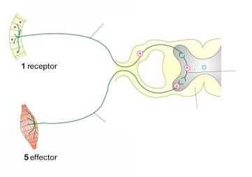
2.
6.
4.
3.

The receptors are in the __________ .

The effector is ____________________________.

The response is __________________________________________.

These reflexes are very fast. Explain how this helps us to survive.

……………………………………………………………………………………………...

……………………………………………………………………………………………..

……………………………………………………………………………………………...

……………………………………………………………………………………………..

……………………………………………………………………………………………..

……………………………………………………………………………………………..

Hypothesis:

Independent variable (manipulated)

Dependent variable:(measured)

Materials:

Method:
Results

My reflex response times:

Test Number | Measurement of Response Time / cm
1
2
3
4
5
6
7
8
9
10

My average reflex response measurement is __________ cm.

For the whole class:

Gamers average reflex response __________ cm

Non-gamers average reflex response __________ cm

The difference between gamers and non-gamers is _________ cm.

What the results show: ____________________________________________________________________________________________________________________________________________________________________________________________________________________________________________________

Recall the Hypothesis: (What your group was testing)

Discussion

Problems encountered in the experiment

Effects of experimental errors

How could the experiment be improved to create a more reliable and rigorous test

Conclusion:

Recommendations:

